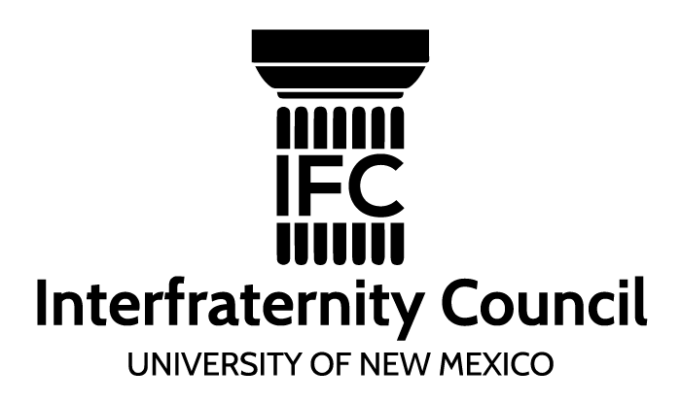

2017 IFC Expansion Committee Application

The IFC Expansion Committee has an exciting opportunity to expand our existing Greek Life at UNM and grow to ten IFC chapters by 2020. Members of this committee will be tasked with deciding which new IFC Fraternities will be slated to join UNM’s Greek Community and when they will be slated to start. We will be selecting a committee member from each existing chapter on campus for a total of six committee members. Matt Lumpp, Assistant Greek Life Advisor and Dominic Colosimo, IFC External Vice President, will oversee the committee and facilitate meetings. We are currently in the process of gathering application packets from chapters around the nation who are interested in coming to UNM in the future.

Application Procedures/Deadlines:
- Applications are due February 10th to the Greek Life Office or to mlumpp@unm.edu, dcolosimo@unm.edu
Mandatory Dates for Elected Committee Members:
- March 9th-11th 2017- Evenings during the last two days of school before Spring Break and the morning of the first Saturday of Spring Break
*Must be present these dates as we will be reviewing application packets as a committee
Requirements:
- Must be a member of an IFC Fraternity on campus and initiated before or during the Fall of 2015
- Must have above a 3.0 cumulative GPA

Name: Anticipated Graduation Date:_________________

Chapter Affiliation: ___________________ Semester Initiated:

Phone Number: ________________ Email Address: ____________________________

Fall 2016 GPA: ________________ Cumulative GPA: ________________________

Why are you interested in serving on the Interfraternity Council Expansion Committee?

What ideas or insights do you bring to this committee?

What leadership roles have you held within or outside your chapter?

Are you available during the required days?

By signing below, I give permission for the Greek Life Office to verify my grade point average.

Signature: _______________________________ Date: ___________________________

UNM ID: ___________________________

Please email your application to mlumpp@unm.edu, dcolosimo@unm.edu or drop it off with Matt Lumpp at the Greek Life office no later than 5:00 PM on February 10th 2017.

